From Matthew 28 and Acts 1

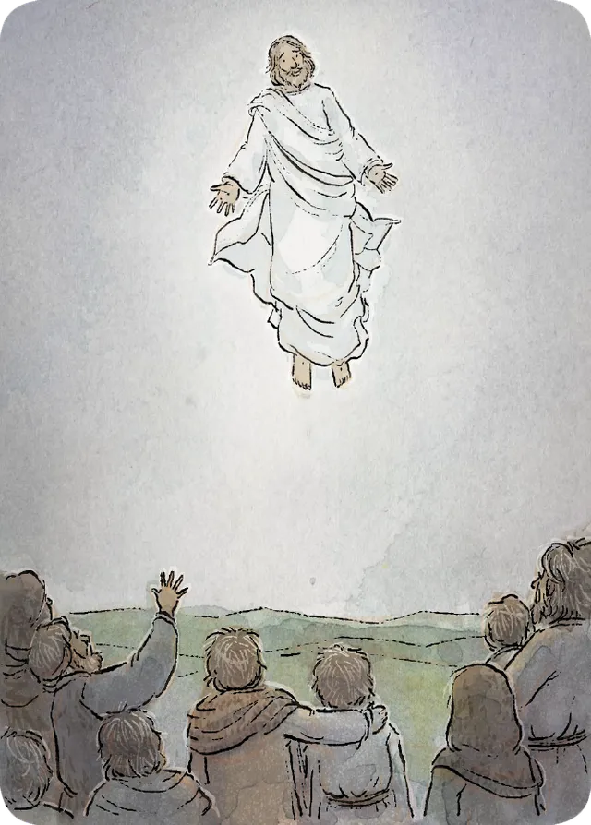

After Jesus died and was resurrected, He visited His followers. He told His Apostles to teach all people to obey the commandments and be baptized.

Peter was now the prophet who would lead the Church on earth. Jesus promised that the Holy Ghost would be with them.

After teaching His followers, Jesus returned to heaven.

The Apostles started traveling and teaching people in different lands.

I can help share the gospel too. I can be a good friend and stand up for what’s right.